**CS 486/586 Introduction to DBMS**

**Spring 2022**

**Assignment 3 – Subqueries, Views**

**Due: Friday, Apr 22, 11:59PM on Canvas**

**Submitted by: - Parth Parashar and Kirtan Patel**

**Part I - Subqueries (60 pts total)**

**1)** List the name of the mission with the lowest [mission_id](http://dbclass.cs.pdx.edu/redirect.php?server=localhost%3A5432%3Aprefer&database=f20tdb74&schema=spy&table=mission&subject=table&sortkey=1&sortdir=asc&strings=collapsed&page=1). (20 points)

**Answer: -**

select name from mission where mission_id = (select min(mission_id) from mission);

The screenshot depicting the query and its result is given below: -

**2)** List the agents (agent_id, first, last) who have been on a ‘Presidential’ mission that succeeded. (20 points)

**Answer: -**

SELECT agent_id, first, last FROM agent WHERE agent_id IN (SELECT tr.agent_id FROM teamrel tr, mission m WHERE TR.team_id = m.team_id AND m.access_id IN (SELECT sc_id FROM securityclearance WHERE sc_level = 'Presidential') AND mission_status = 'success');

The screenshot depicting the query and its results is given below: -

1. Creating a view to store the results (as the number of rows is 142 for this select query)

create view testing

as

(SELECT agent_id, first, last FROM agent

WHERE agent_id IN

(SELECT tr.agent_id FROM teamrel tr, mission m

WHERE TR.team_id = m.team_id AND m.access_id

IN (SELECT sc_id FROM securityclearance

WHERE sc_level = 'Presidential')

AND mission_status = 'success'));

1. Checking the count of rows in this view

1. Displaying the result rows using select * from testing limit 40;

**3)** Find the skill and the number of people, that the most people have that skill(s). (20 points)

**Answer: -**

SELECT skill_id, COUNT(agent_id) FROM skillrel GROUP BY skill_idORDER BY COUNT(agent_id) DESC LIMIT 1;

The screenshot below depicts the result of the above query: - 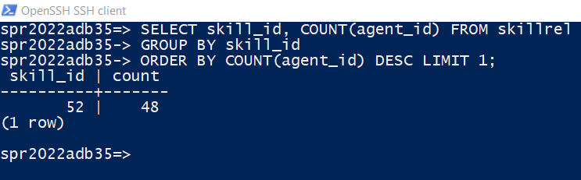

Method-2: -

SELECT r.skill_id, s.skill, COUNT(r.agent_id) FROM skill s, skillrel r where r.skill_id = s.skill_id GROUP BY r.skill_id,s.skill ORDER BY COUNT(r.agent_id) DESC LIMIT 1;

**Part II - Views (40 pts total)**

**4)** Write an SQL view definition that displays agent names (first, last), the affiliation they belong to and the description of the affiliation(s). Show your view definition and the first 5 rows returned when you SELECT * from the view, and the row count. (20 points)

**Answer: -** CREATE VIEW agent_affiliation AS SELECT ag.first, ag.last, af.aff_id, af.description FROM agent ag, affiliation af, affiliationrel afr WHERE ag.agent_id = afr.agent_id AND afr.aff_id = af.aff_id;

The screenshot below gives the create view, count of tuples in view and lists some of the records

**5)** Write an SQL view definition that displays unique mission (name), the team(name) that performed this mission and the text of the missions security clearance level (access id) and description. Show your view definition and the first 5 rows returned when you SELECT * from the view, and the row count. (20 points)

**Answer: -** CREATE VIEW mission_sub AS SELECT DISTINCT m.name mission_name, t.name team_name, s.sc_level, s.description FROM mission m, team t, securityclearance s WHERE m.team_id = t.team_id AND m.access_id = s.sc_id;

The screenshot below gives the creat view, count of elements in the view and lists down some of the elements of the view: -

